Budget Spreadsheet

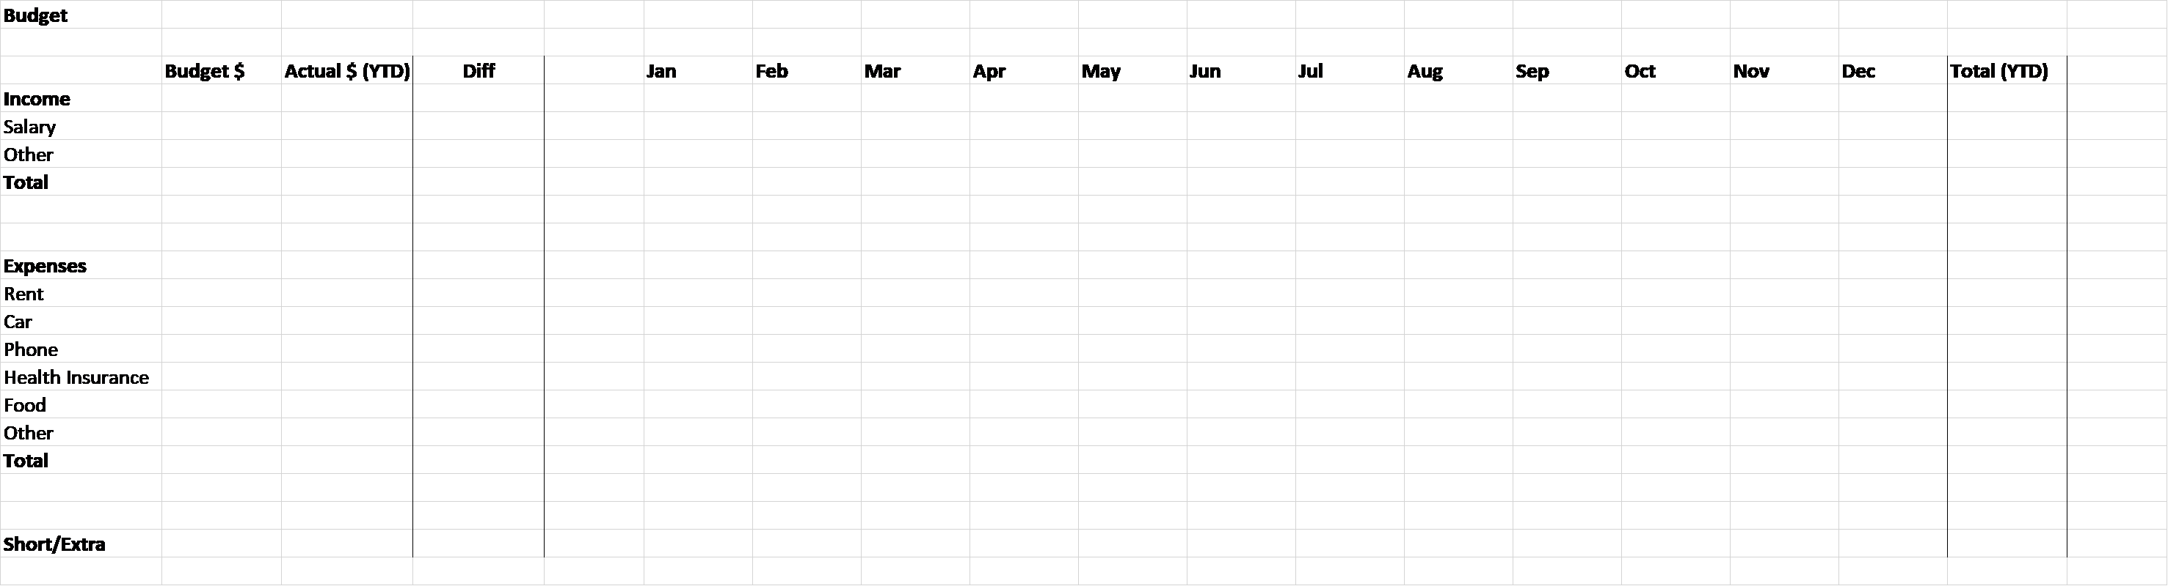

Food Expenses:

